Spring AI addresses the fundamental challenge of AI integration: Connecting your enterprise Data and APIs with AI Models.
- Support for all major AI Model providers such as Anthropic, OpenAI, Microsoft, Amazon, Google, and Ollama. Supported model types include:
- Chat Completion
- Embedding
- Text to Image
- Audio Transcription
- Text to Speech
- Moderation

Ollama Chat

Prerequisites
You first need access to an Ollama instance. There are a few options, including the following:
1)Download and install Ollama on your local machine.

- after install ollama in system
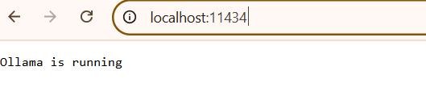
- GO to Ollama=> serach for mistral model (https://ollama.com/library/mistral)
3)open command prompt
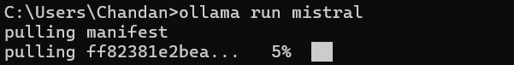
- check the list
=>ollama list

Spring boot project

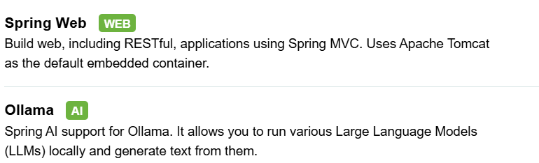

Properties file
spring.application.name=Spring-ai
spring.ai.ollama.base-url= http://localhost:11434
spring.ai.ollama.chat.options.model= mistral
spring.ai.ollama.chat.options.temperature= 0.7
server.port=4041

@RestController
public class TestAiController {
@Autowired
private OllamaChatModel chatModel;
@GetMapping("/ai/generate")
public Map<String,String> generate(@RequestParam(value = "message", defaultValue = "Tell me a joke") String message) {
return Map.of("generation", this.chatModel.call(message));
}
@GetMapping("/ai/generateStream")
public Flux<ChatResponse> generateStream(@RequestParam(value = "message", defaultValue = "Tell me a joke") String message) {
Prompt prompt = new Prompt(new UserMessage(message));
return this.chatModel.stream(prompt);
}
}

